ServSafe® Manager Certification

REGISTRATION FORM
Email: linda@safefoodms.com Phone: 228-326-9161 Mail to: 15327 Swan Court Gulfport, MS 39503

(Please Print)
PLEASE NOTE: Registration form must be completed in entirety in order to be processed. This includes payment information. If you miss a class a $40 reschedule fee is required and admits you into the next class on schedule. Visit www.SafeFoodMS.com for class schedules and more information. NO refunds will be issued. Good for 90 days. I do NOT cancel class unless act of God.

 | Today’s Date:
 | mAILING INFORMATION (cOURSE bOOKS AND CERTIFICATES WILL BE MAILED TO THIS ADDRESS)
 | Last name: |  |  |  |  |  |  |  |  |  | First name:
 | Company Name: |  |  |  |  |  |  |  |  | Work number: |  |  |  |  |  | Cell number:
 |  |  |  |  |  |  |  |  |  | ( ) |  |  |  |  |  | ( )
 | Street address: |  |  |  |  | City: |  |  |  |  |  | State: |  |  |  | ZIP Code:
 | Last 4 Social Security numbers: |  |  |  |  | Email: |  |  |  |  |  |  |  |  |  | Fax number:
 |  |  |  |  |  |  |  |  |  |  |  |  |  |  |  | ( )
 | SELECT ONE: Online Exam or Pencil/Paper Exam
 | Write in Class Date here:
 | (If registering one week before class, it is the student’s responsibility to make arrangements to pick up book. All certificates will be emailed to email address given.)
 | Select One: |  | MHRA Members Only!  $140.00 Manager Certification Course 1-Day Course, book & exam  Membership #__________  Online 90 Day ServSafe® Original Course & $200.00 Proctored Exam in Gulfport/Biloxi Area  2-Hour Private Individual $125.00 Proctoring Exam |  |  |  |  | 1-Day Course, Book & Exam $160.00  1-Day Course & Exam-no book $115.00  1-Day Course & Exam Retest Fee  $85.00 (Failed exam)  Reschedule -1-Day Course & Exam $40.00 (Missed class) |  |  |  |  |  |  |  | ServSafe Manager’s Certification Course  *This course meets Mississippi, Alabama & Louisiana Department of Health requirements and is the original ServSafe® Food Safety Manager Certification which includes an exam.
 | Book Language Preference: |  |  |  | English |  | Spanish |  |  |  | Chinese |  |  | Spanish |  |  |  | Korean
 | Exam Language Preference: |  |  | English |  |  | Spanish |  |  |  | Chinese |  |  | Spanish |  |  | Korean

Payment Information:
 |  | ( ) I have enclosed a certified check or money order. Make payable to: Linda Craft/SafeFoodMS  ( ) I authorize a credit card payment: Initial here_______  Card Type: _________________ Card # ____________________________________ CSC______  Expiration Date __________________ Name on Card ____________________________________  Billing Address_____________________________City________________________Zip_____________ |  |  |  |  |  |  |  |  |  |  |  |  | 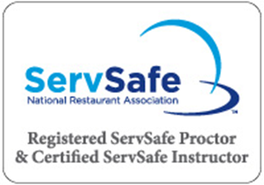
ServSafe® Manager Certification Classes
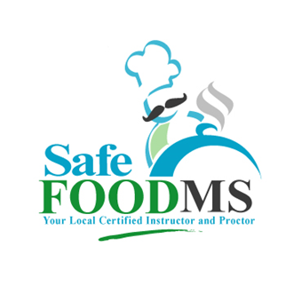

NEW YEAR 2022
Location: KROC CENTER
575 DIVISION STREET, MISSISSIPPI 39532

- Monday, January 3, 2022
- Monday, January 17, 2022
- Monday, February 7, 2022
- Monday, February 21, 2022
- Monday, March 7, 2022 Closed
- Monday, March 21, 2022 Closed
- Monday, April 4, 2022
- Monday, April 18, 2022
- Monday, May 2, 2022Closed
- Monday, May 23, 2022
- Monday, June 6, 2022
- Monday, June 13, 2022
- Monday, June 27
- Monday, July 11
- Monday July 18
- TUESDAY, AUGUST 9, 2022 Location: Dixie Que, 3036 MS-43, Picayune, MS 39466
- Monday, August 15 Location: Parrish Restaurant, 217 E Beach Blvd, Long Beach, MS 39560
- Monday August 22
- Monday, September 5, 2022 LABOR DAY
- Monday, September 19, 2022
- Monday, October 3, 2022
- Monday, October 17, 2022
- Monday, November 7, 2022
- Monday, November 21, 2022
- Monday, December 5, 2022
- Monday, December 19, 2022

BoomTown Casino, 676 Bayview Ave, Biloxi, MS.
- Monday, May 16, 2022

*You may call (228-326-9161) and I can take payment and registration over the phone.
*You may visit www.safefoodms.com to register and pay although some may not be on the website.
*You will receive study guides and a confirmation email. Let me know and I will gladly provide an invoice or receipt.

Email: linda@safefoodms.com Phone: 228-326-9161 Website: www.safefoodms.com

